Report about conducted load test
Date: 24.07.2022
Author: Shushanik Tonoyan

Application: BlogEngine.NET version 3.2
Environment: Test Environment

Test Environment configuration (RAM, CPU etc.):
Processor | Intel(R) Core(TM) i7-10610U CPU 1.80 GHz 2.30 GHz
RAM | 3.95 GB
System type | 64-bit operating system
Operating System | Windows 10 Enterprise 21H1

- Why such testing was conducted: Performed load test for different configurations of test environment to determine the optimal configuration.

- Test script description:
The following script should be run for
- Anonymous script with probability usage is implemented according to the following table
Flow | Execution percentage %
Home Page | 15
Open Random Date | 10
Open Predefined Date | 30
Search by Name | 30
Open Large Calendar | 10
Open Contacts | 5
Open Random page (yes/no) | 50/50
Open post (yes/no) | 80/20
Random or First | 65/35
Comment (yes/no) | 20/80
- Admin script
- Editor script
Anonymous script
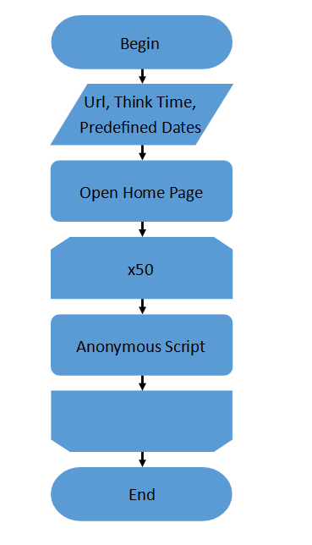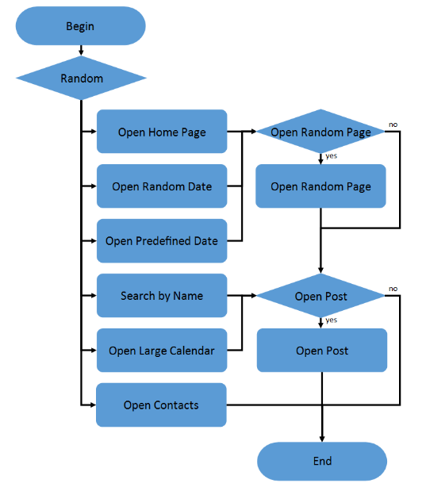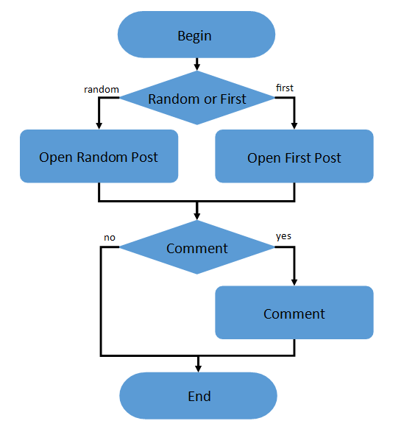

Admin Script
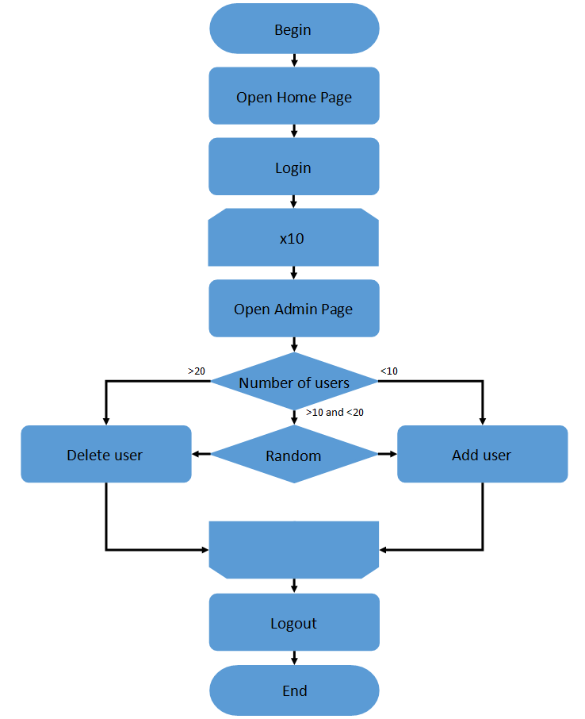

Editor Script
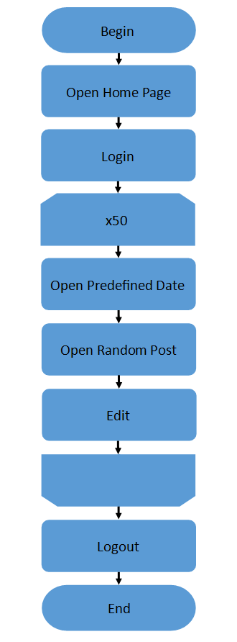
- Tests:
Metrics to monitor: average throughput, response time 95th percentile, error rate, and CPU usage.
Test run preconditions: 2 admins, 2 editors should be created, and 1000 posts created by different users.
Base configuration: CPU count 1, RAM 4 GB. For the mentioned configuration, the capacity test has been conducted. According to the capacity test, the saturation point is around 95 users, and the application stays in the comfort zone while the users count is less than 75 users. On the base of this results, the average load was defined to be 40 users.
Load Model:
The scalability test for the application under test were conducted. On the base of the capacity test the average load was defined.
Average load: as 40 virtual users.
Load testing. Test was conducted overall for 40 users, duration 900 sec, constant delay between requests 2 sec with deviation 0.10 sec.
Users | Threads count | Rampup in seconds
Admins | 2 | 120
Editors | 4 | 120
Anonymous Users | 34 | 120

- Short summary on conducted tests:
Detailed test results presented on the section 5 of the report. Further the CPU count was increasing by one for each next run, the RAM was the same. According to my test results increase of CPU count from 1 to 2 affects throughput and response time dramatically (growth of throughput by almost 50% and decrease of response time by 82%). Further increase of CPU count reflected on mentioned KPIs much less (growth of throughput by 5% and decrease of response time by 36%). So, the scaling is not linear. The best configuration was determined as CPU count 3 and RAM 4 GB. Then the RAM was decreased by 1 GB on each step. According to the test result the RAM decrease led to the degradation of KPIs, but the CPU count has more impact on the KPIs.

- Detailed test results:
Comparison of results for different configurations
RAM 4 GB
 | 1 CPU | 2 CPU | 3CPU
Throughput (Req/s) | 11.13 | 16.53 | 17.36
Response Time 95th percentile | 3.05 s | 535.40 ms | 341.06 ms
Error Rate % | 0.1 | 0.24 | 0.26
CPU usage % | 41.2 | 39.5 | 16.0

3 CPU
 | 2 GB | 3 GB | 4 GB
Throughput (Req/s) | 14.8 | 16.96 | 17.36
Response Time 95th percentile | 394.16 ms | 417.14 ms | 341.06 ms
Error Rate % | 0.26 | 0.25 | 0.26
CPU usage % | 18 | 28.0 | 16.0

1 Configuration (1 CPU, 4 GB RAM)
 | max | avg | min
Throughput (Req/s) | 20.00 | 11.13 | 0.20
Response Time 95th percentile | 11.04 s | 3.05 s
Error Rate % | 0.1
CPU usage % | 85.3 | 41.2 | 3.31

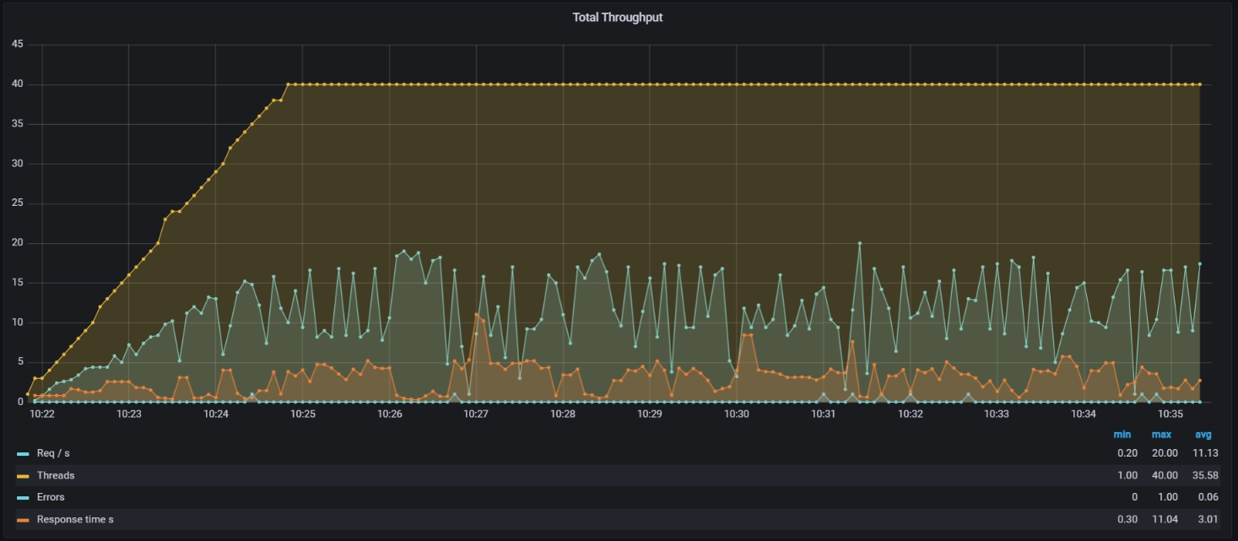
As follows from the chart and the table below, and the average throughput during this run is 11.13 request, average response time is 11.04 s.
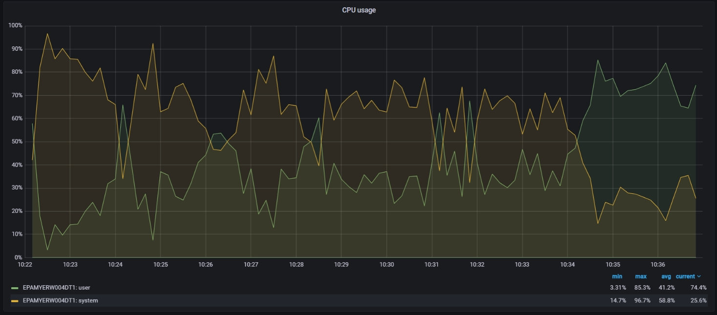
2 Configuration (2 CPU, 4 GB RAM)
 | max | avg | min
Throughput (Req/s) | 22.40 | 16.53 | 0.20
Response Time 95th percentile | 4.09 s | 535.40 ms
Error Rate % | 0.24
CPU usage % | 99.3 | 39.5 | 10.8

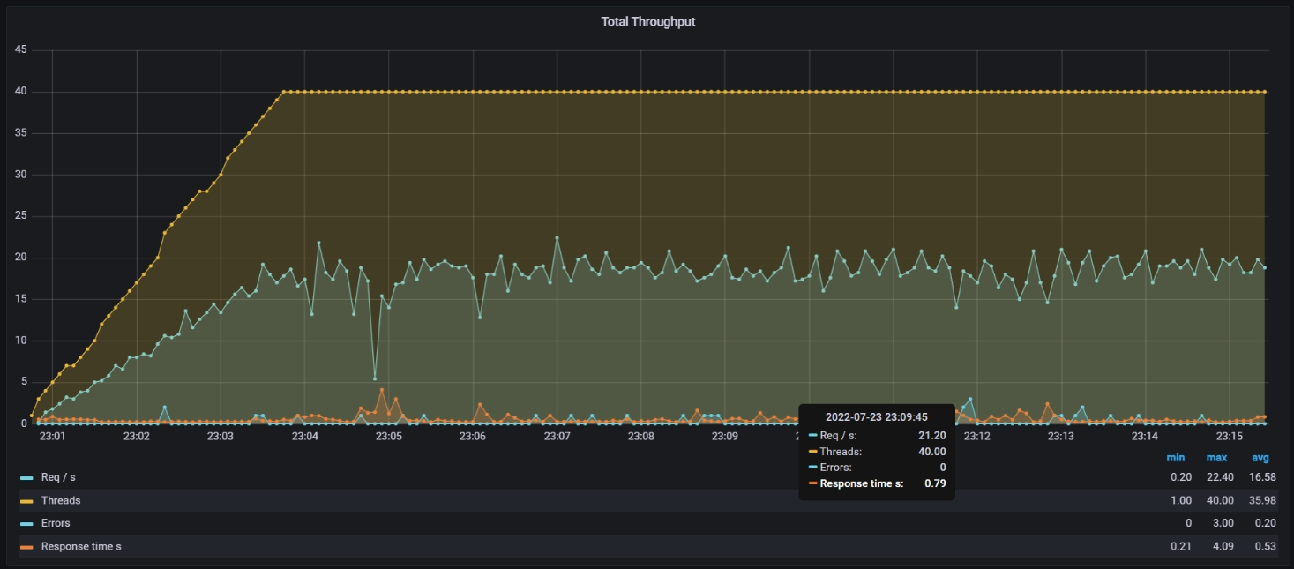
After adding second CPU, the results have been improved. The throughput increased by 48.5% and became 16.53, response time decreased by 82.2% and became 535.40 ms. CPU usage decreased by ~4%.

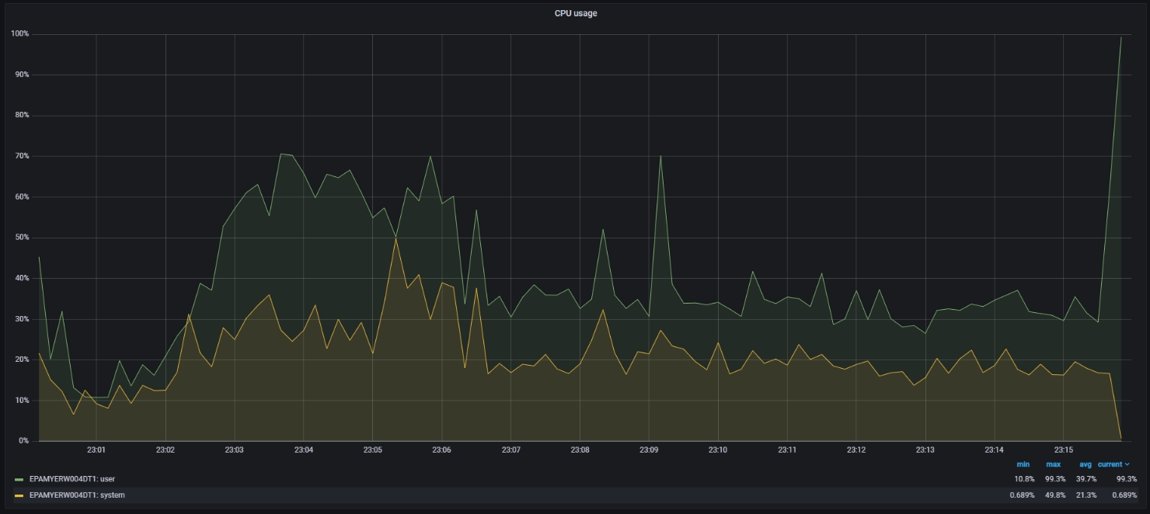
3 Configuration (3 CPU, 4 GB RAM)
 | max | avg | min
Throughput (Req/s) | 24.60 | 17.36 | 1.00
Response Time 95th percentile | 1.16 s | 341.06 ms
Error Rate % | 0.26
CPU usage % | 52.7 | 16.0 | 1.51

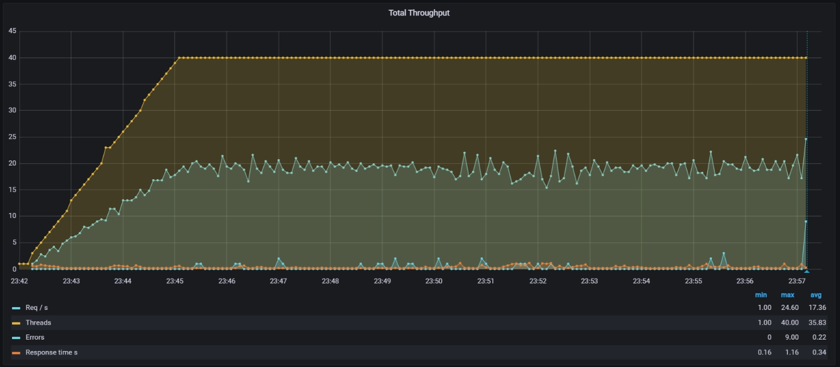
The further addition of the third CPU increased average throughput by 5%, and decreased response time by 36.3%. The CPU usage decreased by ~60%.
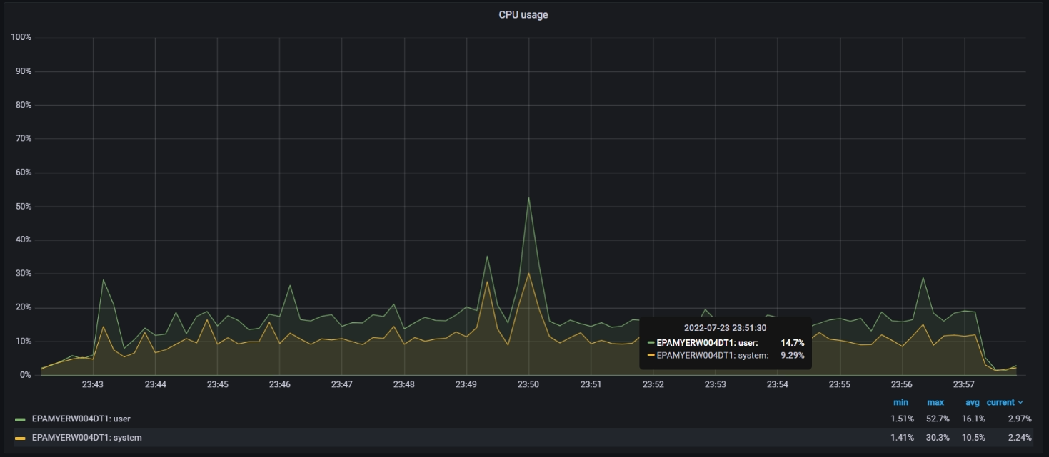
4 Configuration (3 CPU, 3 GB RAM)
 | max | avg | min
Throughput (Req/s) | 23.80 | 16.96 | 0.20
Response Time 95th percentile | 3.99 s | 417.14 ms
Error Rate % | 0.25
CPU usage % | 52.0 | 28.0 | 6.30
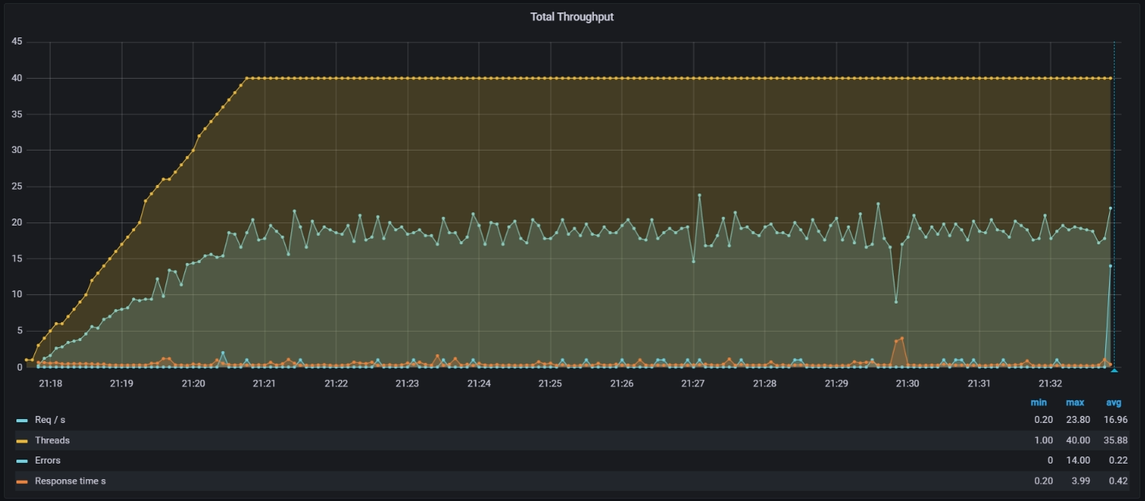
If we keep 3 CPUs but decrease RAM from 4 to 3 GB, the small degradation by 2.3% in throughput observed. The response time increased by 22%.CPU usage increased by 75%.
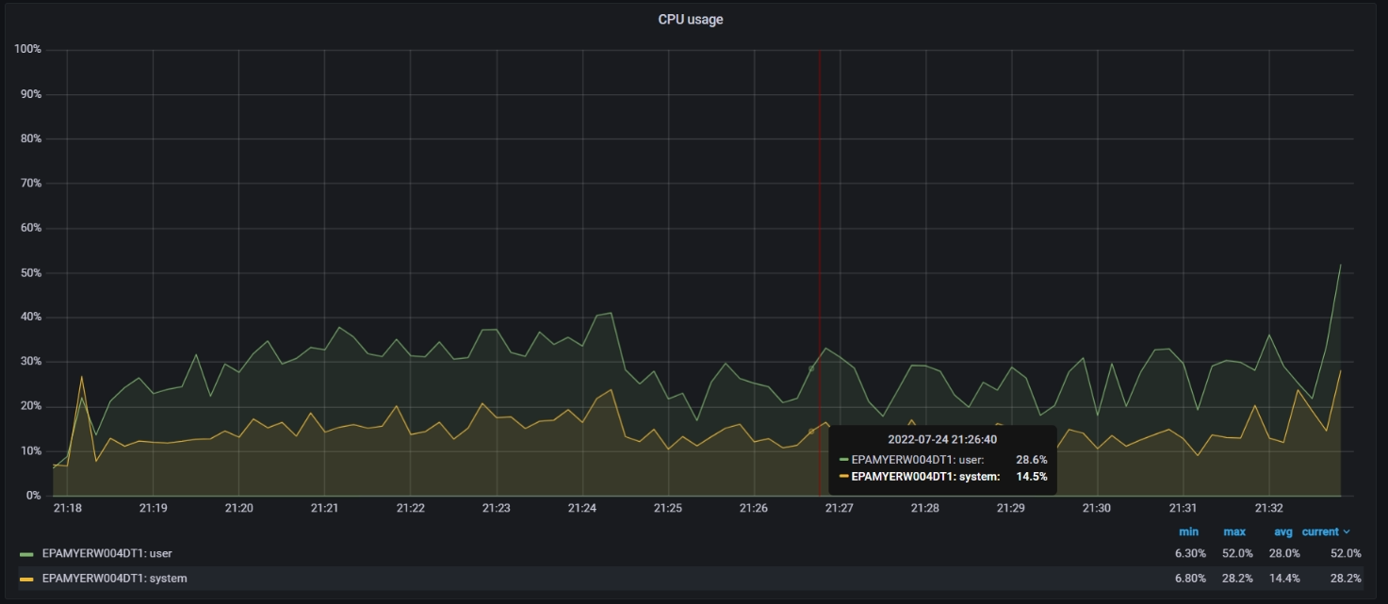
5 Configuration (3 CPU, 2 GB RAM)
 | max | avg | min
Throughput (Req/s) | 24.80 | 14.08 | 1.20
Response Time 95th percentile | 1.65 s | 394.16 ms
Error Rate % | 0.26
CPU usage % | 54.3 | 18.0 | 0.76

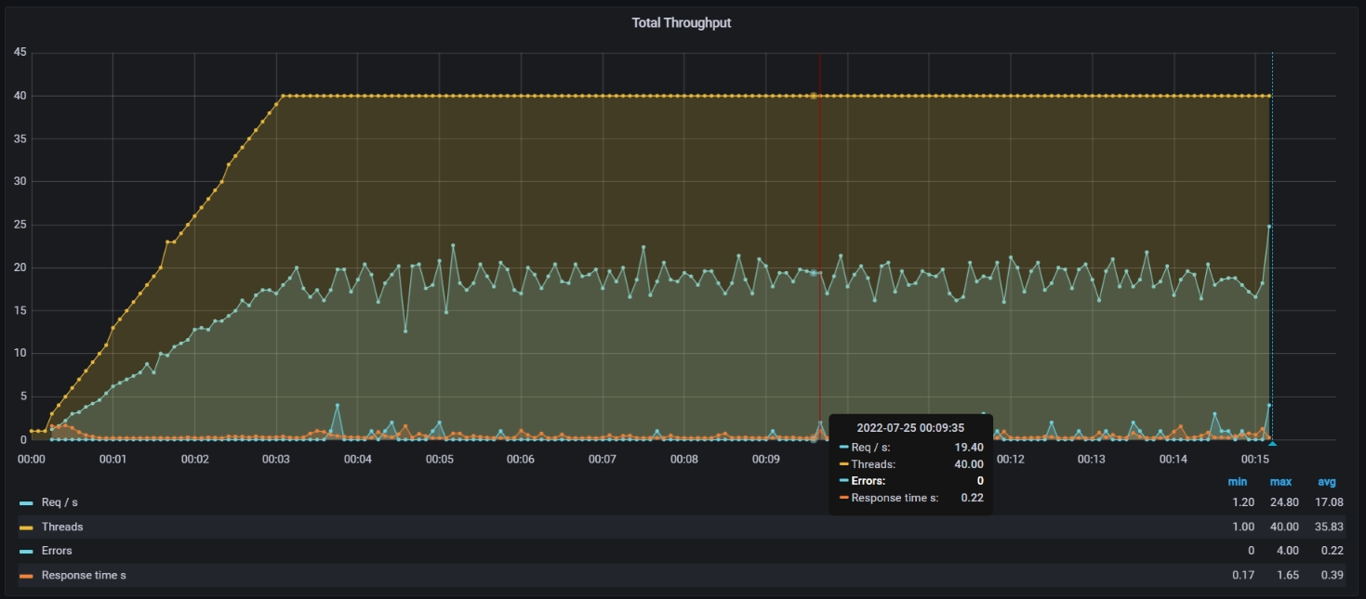

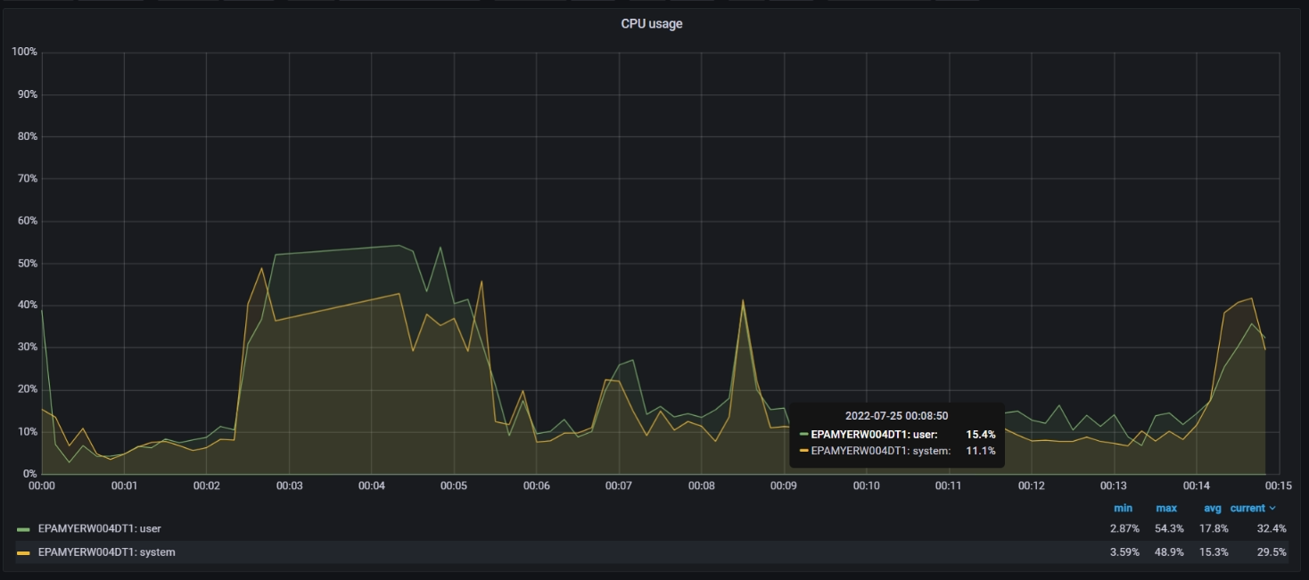

- Conclusion: On the base of the conducted load tests result the optimal configuration has been selected as the following:
CPU count | 3
RAM | 4 GB

